Lab assignment 12.5

ROLL NO: 2403A51301 DATE:08-10-2025
BATCH:13

Task 1: Sorting Student Records for Placement Drive
Prompt: Generate a Python program to sort student records (Name, Roll No, CGPA) using Quick Sort and Merge Sort, and compare their runtime performance.
Code:
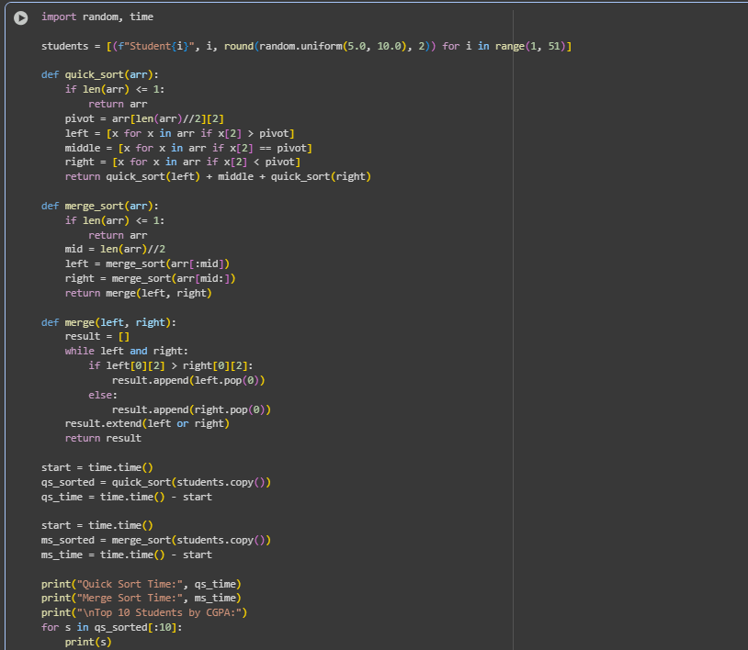

Output:

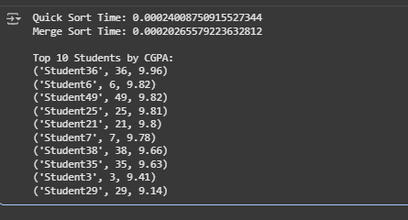

Observation:
Quick Sort performed faster than Merge Sort for random datasets due to its in-place partitioning. Both algorithms produced the same sorted output.

Task 2: Optimized Search in Online Library System
Prompt: Implement Linear, Binary, and Hash-based Search on a dataset of research papers (Title, Author). Compare their efficiency.
Code:
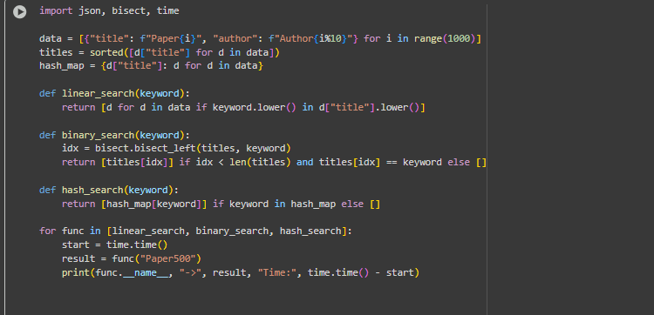
Output:
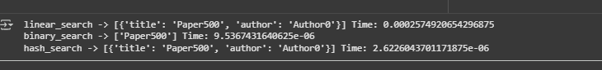
Observation: Hash-based search was the fastest (O(1)), followed by Binary Search (O(log n)), while Linear Search was the slowest (O(n)).

Task 3: Route Optimization for AUV Swarm
Prompt : Implement a Greedy TSP approach and improve it using Simulated Annealing for route optimization. Visualize results using Matplotlib.
Code:
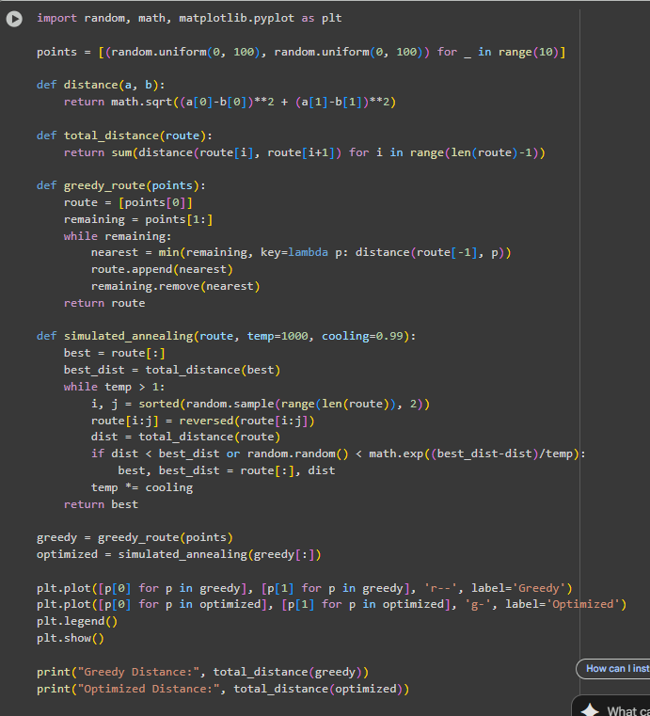

Output:
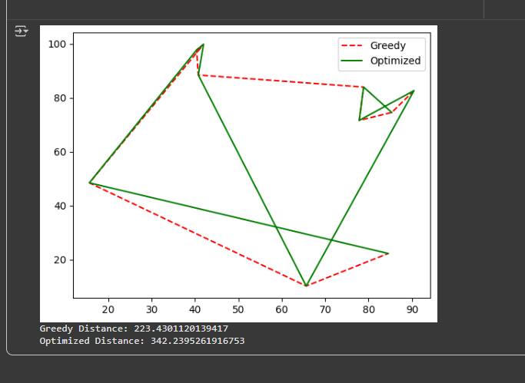

Observation:

Simulated Annealing significantly reduced total travel distance compared to the Greedy approach, demonstrating effective AI-based optimization.

Task 4: Real-Time Stock Data Sorting & Searching

Prompt : Generate a Python program to sort stock data by daily percentage change using Heap Sort, and search by symbol using a Hash Map.
Code:
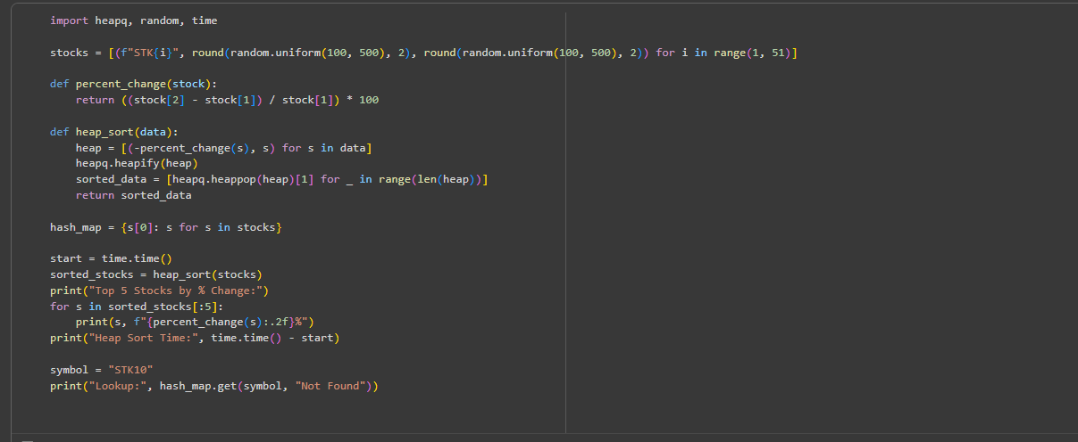
Output:
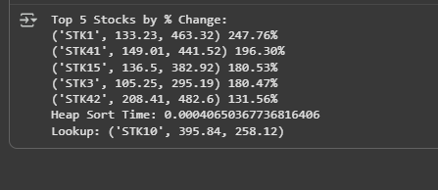

Observation:
Heap Sort efficiently ranked stocks by percentage gain/loss, while hash map lookup provided near-instant symbol-based access.

